ASTER Header Transfer Tool Users Guide

This program allows you to transfer the special header information contained in an ASTER scene that has been imported into Imagine. Currently the header information is lost during reprojection or subsetting. This tool transfers the information from the originally imported file, to the reprojected (or subsetted) file that is missing the data. Please note that when subsetting in imagine, you MUST keep all of the original layers or the transfer will not work. To do this simply leave the “Select Layers” field unchanged after you select the file wish to subset, as it chooses all layers by default. The reason you must keep all of the layers is that Imagine renames the layers of the output file to simply “layer_1”, “layer_2”, etc, so there is no way to know what layers in the output file correspond to what layers in the input file, unless all of them remain in the same spot.

This utility also allows you to transfer header information to “stacked” images, meaning that if you use the layer stacking utility to combine several images (we currently support up to 3 images) into one large image. The same rules regarding layers apply to stacking as well as subsetting. When you are using the layer stack utility, you must select “All” in the “Layer” input field for each image. One VERY IMPORTANT thing to note is that the order of your input images must correspond EXACTLY to the order in which you stacked them. For example, if you had three images, say “im1”, “im2”, and “im3” and you build a stacked image with “im1” on top of “im2” which is on top of “im3”, then the order of your input files MUST be “im1”, “im2”, “im3”. IF YOU DO NOT MAINTAIN THE IMAGE ORDER THAN THE TRANSFERRED DATA WILL BE WRONG FOR EVERY LAYER. One last thing to note is that if you are using multiple input images to transfer data to a stacked image, then the “HDFGlobalAttributes” data will not be transferred. This is because only one “HDFGlobalAttributes” entry is supposed to exist for a file, and it is unique for that file. If you are transferring data from 2 or more files you can’t just pick any “HDFGlobalAttributes” entry to transfer to the output file, since it is unique for its particular input file.

The interface is extremely simple. All you have to do is select each input file that you wish to transfer data from, select the output file to transfer the data to, and click “OK”. The transfer will then be performed.

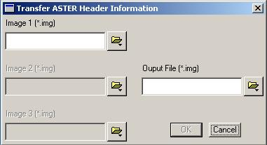

Before Transfer

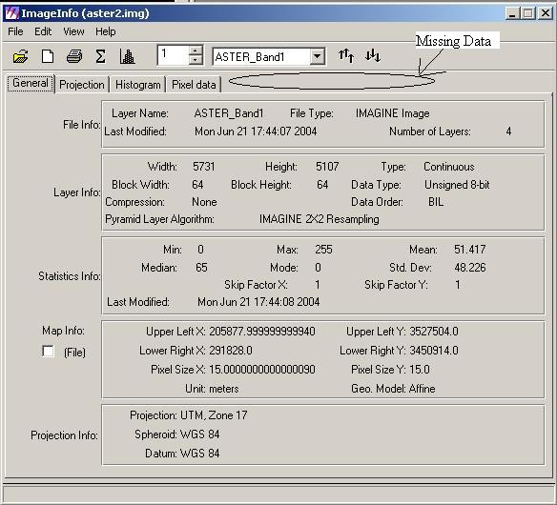

After Transfer

